Metadata

For

**LandAdvisor Little Karoo v3.2 Sample Data**

**Published: 2013**

**By John A. Galloa1**

a: Botany Department, Nelson Mandela Metropolitan University, Nelson Mandela Bay, South Africa

1: current address: [gallo.ja@gmail.com](mailto:gallo.ja@gmail.com)

Corresponding Paper, model, discussions are found at <http://landscapecollaborative.org>

Table of Contents (with hotlinks)

Introduction 2

Audience and Content 2

Data and Pre-Processing 2

Habitat Data 2

Species Data 2

Sites 5

Habitat Conservation Targets 6

Transformation Data 6

“Protected” Areas 8

Cost Data 8

Calculation of Management Costs for Acquired Properties 11

Cost of Stewardship for each property 11

References 13

Introduction

Audience and Content

This document provides additional information about the data for the associated manuscript and case study. To aid in the use of the document, hotlinks are provided from the table of contents and at the bottom of each page. This document was written primarily for any readers of its associated publication that are interested in applying some of the ideas to their own work. Further, it was written for end-users in the Little Karoo and the Western Cape as a complement to the workshops and final result presentations. There is a fifty page document of raw notes and methods that is available upon request.

It is not the responsibility of the Journal to edit this supplementary material. It does not comply to all of the Journal’s formatting standards.

Data and Pre-Processing

Habitat Data

The vegetation map used for this analysis was created for the Little Karoo region through extensive field surveys during 2004 by local botanical expert Jan Vlok. Numerous site visits complemented remote sensing interpretation, and then individual polygons where hand drawn on 1:50 000 Landsat images and hand digitized (Vlok et al. 2005). A hierarchical classification system was used, in which sub-habitats (vegetation units) were nested within habitat polygons, which were nested within biome polygons. In areas that were transformed (i.e. degraded or developed), the pre-transformation vegetation was estimated and mapped based on clues from the surrounding vegetation and micro-locations of low degradation, such as the corners of pastures. To be clear, the vegetation map does not have any categories for urban, suburban, etc. Local knowledge, where available, was also utilized.

Species Data

CapeNature’s in-house “State-of-Biodiversity” excel database was used for this project. There were approximately 70,000 species observation records in the database for the region. These are plant and animal species, and include listed or unlisted species. Special thanks goes out to the external organizations that augmented CapeNature’s database by donating their data and giving special approval for use by this case study: The Avian Demography Unit at University of Cape Town, the Herpetology Lab at Stellenbosch University, Tony Robelo and the Protea Atlas, Iziko Museums of Cape Town, Albany Museum, Transvaal Museum, South African Institute for Aquatic Biodiversity, and Bayworld.

Several pre-processing steps were required:

The excel database was converted to a point shapefile.

The polygon of each observation was mapped.

* Each observation had a spatial precision documented, or was cross referenced to a reserve or sub-reserve polygon. The point shapefile was converted into a polygon shapefile, such that the boundary of each observation was mapped. Hence, if an observation took place within 100 m of a known coordinate, then it was represented by a circle with a 200 m diameter, centered at the coordinate.

All observations with a spatial precision worse than 2 km were removed.

The status categories were standardized across all species.

* The database has three columns for status: IUCN Status, Red list Status, and the South Africa Rare Database.
* I first overlaid them into one Field, in which Red_list took precedence over SANDNAme, which took precedence over IUCN Name. (This prioritization is based on recentness of the classification list, and number of records; it would be ideal to instead take the most endangered listing of all three columns.)
* I then standardized the 30+ categories into the following seven categories: Critically Endangered or Critically Rare; Endangered or Rare; Vulnerable; Near Threatened; Least Concerned; Status Indeterminate; and Extinct. See Table 2.

Table 2. Standardization of Species Classifications

|  |  |
| --- | --- |
| **Status in Database** | **Standardized Status** |
|  |  |
| CR | Critically Endangered or Rare |
| Critically Endangered (C2a) | Critically Endangered or Rare |
| Critically Rare | Critically Endangered or Rare |
| Data Deficient | Status Indeterminate |
| DD | Status Indeterminate |
| Declining | Near Threatened |
| EN | Endangered or Rare |
| Endangered (A3c) | Endangered or Rare |
| EX | Extinct |
| Extinct | Extinct |
| Indeterminate | Status Indeterminate |
| Insufficiently Known | Status Indeterminate |
| Least Concern | Least Concern |
| Lower Risk (near threatened) | Near Threatened |
| Near Threatened | Near Threatened |
| Near Threatened (A1c+2c) | Near Threatened |
| Near Threatened (A1c+2c, B1+2bcde, C1) | Near Threatened |
| Near Threatened (A1c+2cd) | Near Threatened |
| Near Threatened (A2c) | Near Threatened |
| Near Threatened (C1) | Near Threatened |
| Near Threatened (C2a) | Near Threatened |
| Near Threatened (D1) | Near Threatened |
| Not Threatened | Least Concern |
| NT | Least Concern |
| Rare | Endangered or Rare |
| VU | Vulnerable |
| Vulnerable | Vulnerable |
| Vulnerable (A1a, C1) | Vulnerable |
| Vulnerable (A1a+2b) | Vulnerable |
| Vulnerable (A1a+2b, C1) | Vulnerable |
| Vulnerable (A1ac+2bc, C1) | Vulnerable |
| Vulnerable (A1acd+2bcd, C1+2b) | Vulnerable |
| Vulnerable (A1acde+2bc) | Vulnerable |
| Vulnerable (A1ace) | Vulnerable |
| Vulnerable (A1c+2bc, C1) | Vulnerable |
| Vulnerable (A1c+2c, C1+2a) | Vulnerable |
| Vulnerable (A1ce) | Vulnerable |
| Vulnerable (A2c, C1) | Vulnerable |
| Vulnerable (B1+2abcd, C2a) | Vulnerable |
| Vulnerable (B1ab+2ab) | Vulnerable |
| Vulnerable (C1+2a) | Vulnerable |
| Vulnerable (D1) | Vulnerable |

I created and populated a new variable called number of observations per species in database

(The key was to use the free tool: “field_Mark_Duplicates_2.cal” from Easytools 5.0 from ET Spatial Techniques. The result was dissolved by taxon, taking the maximum value.)

I calculated a spatial precision value for each observation

A common challenge of species observations databases is that the spatial precision of the observation of an individual ranged widely in the database. For example, a zebra seen on a particular date by a particular observer could be mapped to have occurred somewhere in particular ha. A second observation could be mapped to have occurred somewhere in a particular square km. Both observations were of only one zebra.

To account for this issue, the species representation analysis also involved location precision. This value ranges from 0-1, and is assigned to every hectare (ha) on the landscape. A value of 1 indicates high certainty that the species was seen in a particular ha. A value near 0 indicates low certainty. I calculated the “Precision” field by taking the area of the most exact observation in the database (which was “nearest second”), and dividing this area by the area of the observation in question. Thus, when we convert to a grid, the most precise observations get a value of 1 for the hectare they lie on, and all others will get a lower value for the HAs they lie on.

In the analysis, each individual observation was given a total precision value of 1.0, which was then divided among all the cells associated with the observation. Hence, the hectare of the first example would get a location precision value of 1.0, while the 100 hectares of the second example would each get a value of 0.01. This was multiplied by the management quality value of the cell and the habitat integrity value of the cell to get the quality weighted area of the cell.

Many versions of LandscapeDST Little Karoo do not have the species representation value model (it should be in the LandscpaeDST Factory though). Here is a summary of the analysis. The end-users opted for an abridged agenda for the September workshop, so the species representation parameters were not discussed. The default values are illustrated Figure 5 and were used in the implementation of the prototype decision support system. There were about 66,000 records in the database, but many did not have a listing status, or had a spatial uncertainty of greater than 2 square kilometers (the precision threshold used). About 10,000 of the records were used in this analysis.The locations of recently extinct species were included at very low weight because of some uncertainty regarding the designation. If some individuals still exist, known suitable habitat would be of value.

Of special note, the total hectares protected for a species used a quality weighted area approach. Quality weighted area in this case was the precision value times the protected area value. The amount of “area” of species protection that would be provided if a new property is conserved was determined in the same manner.

Figure 5: FDR curves for the various listed species classes

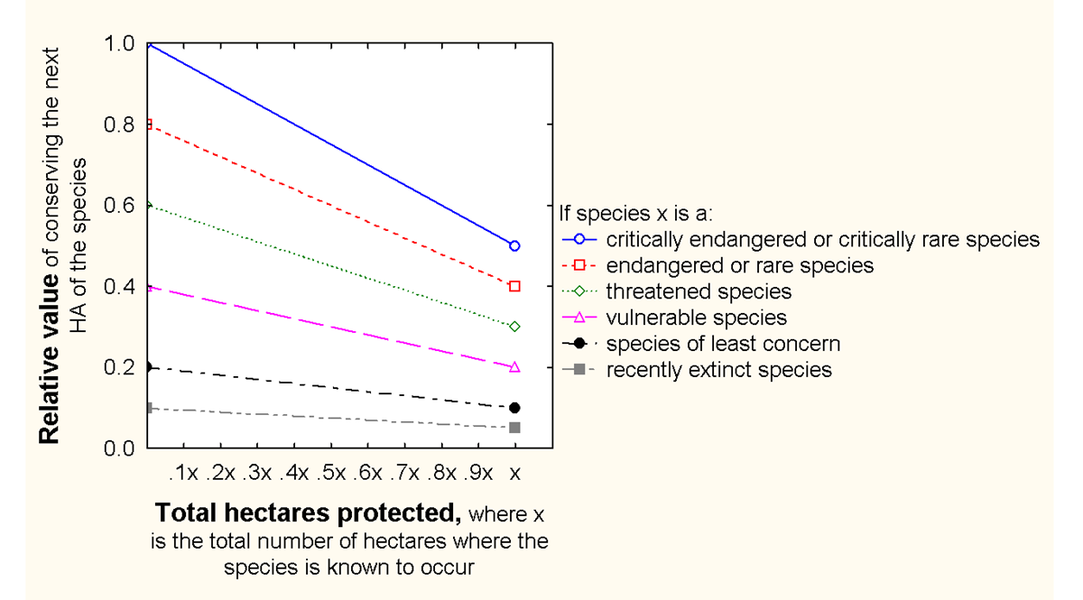

Sites

The cadastre shapefile was provided by CapeNature, and has the polygons of all cadastres in the region, as well as a cadastre identification number. This was joined with a deeds database that had the name of the landowner for each cadastre. All the contiguous cadastres with the same owner were lumped together as a single property (site).

Habitat Conservation Targets

One of the challenging aspects of applying gap analysis is setting the targets. Targets here are the percentages of the total “original” extent of the habitat (not the current extent) that should be conserved (Desmet & Cowling 2004; Pierce et al. 2005; Pressey et al. 2003). This produces larger targets, in terms of extant vegetation, for habitats that have been severely transformed. It also decouples target percentages from further loss of vegetation (Cowling et al. 2003; Pressey et al. 2003).

Setting targets can be done arbitrarily such as the IUCN target of 10%. The targets used here were defined for the Little Karoo study region, for a different project, using a systematic approach (Vlok & Reyers Unpublished). Each target was habitat specific (as per the logic of Pressey et al. 2003), and derived using the slope of the species-area curve (Desmet & Cowling 2004). This benefited habitats with greater species heterogeneity. The percentage of species targeted for conservation needed to be determined. It was set at 75% following the precedent set by two other studies (Pierce et al. 2005), one of which had stakeholder consultation for the issue (Desmet & Cowling 2004). The targets were then re-scaled such that the highest one was 34%, as per the national standard.

Transformation Data

The transformation data (i.e. habitat conversion, condition) was originally based on the work by Thompson et al. (2008; 2005). But after the September workshop, it was suggested to integrate the data created by Don Kirkwood of CapeNature.

The Thompson Data

The vegetation map does not document how degraded the habitat type is at a particular location. Habitat degradation data do exist for South Africa, but they are at the national resolution, and are not especially accurate (Rouget et al. 2006). Fortunately, a fine-scale habitat degradation map was created based on inter- and intra-annual variation of remote sensing imagery (Thompson et al. 2008; Thompson et al. 2005). It was based on ecological theory: in this region, areas of degraded habitat will have more annual plants that need to go from seed to flowering body in one year. In such areas, there will be a large amplitude intra-annual variation in primary productivity. Pristine habitat will have a higher diversity of species, resulting in larger amplitude swings of productivity within the spring compared to the degraded vegetation. Because the amplitude thresholds are different for different habitat types, parameter values were defined for five different general habitat categories. Analysis of the 250 m resolution NDVI data (MODIS) and 30 resolution imagery (Landsat) using this theory resulted in a product that had an 86% accuracy level, which was far superior to the accuracy of the national level data (which was 64%) (Rouget et al. 2006). The published data layer has a resolution of 100 m. Categories of pristine, moderately degraded, and severely degraded habitat were designated (along with cultivated, underwater, and urban land).

The Kirkwood Data

Meanwhile, Dr. Don Kirkwood of CapeNature was creating the “Integrated Biodiversity Layer” which included a transformation classification for the entire Western Cape. The province had a patchwork of existing transformation data layers, such as the Thompson layer, so the final product was a rule-based amalgamation of existing products – sometimes quite complex, sometimes just one good transformation source with minor changes (e.g. updating the National Land Cover Database with Agricultural fields data from the Department of Agriculture). The shapefile: “intgr_lc_sources_&_conf_dd_wgs84.shp” provides details for what transformation layers were used where. The layer is published using 30 m resolution, and designates which classifications are more certain than others. The methodology is forthcoming from Dr. Kirkwood ([don@ecological.co.za](mailto:don@ecological.co.za)).

The Little Karoo data is multiple source and multiple precision. It took the Thompson data as a starting point, and enhanced it with the NLCD and agricultural data. For areas/classes still known to be misclassified, the 2004/5 SPOT5 data was hand digitized (at 1:5000 or better) and manually classified. For the most part, hand digitization occurred for the mapping of quartz patches and riparian vegetation. (Quartz patches are vital succulent hotspots, but often misclassified as degraded by automated remote sensing.)

Integration

The layers were combined using a weighted overlay. The Kirkwood data was split into two layers: the uncertain data and the more certain data. Then, each land cover class was assigned a value between 0 and 1, with 1 being pristine. The Thompson layer was also classified from 0-1 (this classification was done as part of the September workshop). The Thompson Layer was given a weight of 0.667, the Certain Kirkwood layer a weight of 0.25, and the uncertain Kirkwood layer a weight of 0.083. The Thompson layer was given such a high weight because it was the layer that the end-users were most familiar and comfortable with. The 0-1 classifications are provided in Table 3.

Table 3. Numerical classifications for the different transformation layer categories.

|  |  |  |  |  |  |
| --- | --- | --- | --- | --- | --- |
| Transformation Class | Layer | Partnership | Biodiversity | LHSKT | CN |
| No Natural Habitat | Kirkwood Transformation | 0 | 0 | 0 | 0 |
| Natural-Habitats | Kirkwood Transformation | 1 | 1 | 1 | 1 |
| Near Natural | Kirkwood Transformation | 0.7 | 0.7 | 0.7 | 0.7 |
| Degraded (severe) | Kirkwood Transformation | 0 | 0 | 0 | 0 |
| Possible Natural | Kirkwood Trnsfrmtn (Uncertain) | 1 | 1 | 1 | 1 |
| No Natural Habitat | Kirkwood Trnsfrmtn (Uncertain) | 0 | 0 | 0 | 0 |
| Degraded | Kirkwood Trnsfrmtn (Uncertain) | 0 | 0 | 0 | 0 |
| cultivated - severe | Thompson Transformation | 0 | 0 | 0 | 0 |
| moderate | Thompson Transformation | 0.51875 | 0.65625 | 0.51875 | 0.65625 |
| pristine | Thompson Transformation | 1 | 1 | 1 | 1 |
| severe | Thompson Transformation | 0 | 0 | 0 | 0 |
| urban - severe | Thompson Transformation | 0 | 0 | 0 | 0 |
| water - severe | Thompson Transformation | 0 | 0 | 0 | 0 |
| unknown - boundary | Thompson Transformation | 0.5 | 0.5 | 0.5 | 0.5 |

The above values were plugged into the land conservation decision support system (LCDSS) and used in the habitat representation analysis. They became the default values for the species representation analysis, so they do not have to be entered twice. However, the end-user has the ability to override these defaults and enter in appropriate values. For instance, it could be argued that if a critically endangered species is known to use a particular location, this location should be conserved even if it is severely degraded. Due to the abbreviated September Workshop, only the default values were used for the species representation analysis.

Road Data

The road data, used in the connectivity analysis, were classified such that the roads with the highest threat to biodiversity (due mainly to road-kill and deterrence of movement) were classified as a 1, and all others a score less than one. We used a simple approach for this based on the road type, so there is some uncertainty as to the true score of any particular road segment. The road type with the highest volume and speed of traffic had a score of 1, and all the others had a lesser score, relative to their estimated threat posed to biodiversity:

|  |  |
| --- | --- |
| ROAD TYPE | SCORE |
| National Route | 1 |
| Arterial Route | 0.8 |
| Main Road | 0.75 |
| Secondary Road | 0.5 |
| Street | 0.35 |
| Other Access | 0.2 |
| Track/Footpath | 0.15 |

“Protected” Areas

The statutory conservation areas shapefile was provided by Steve Holness of South African National Parks (SANParks). It was the 2007 beta version. It mapped the Type 1 reserves (statutory conservation areas that are owned and managed by the municipal and provincial government agencies). It also mapped Type 2 reserves, namely mountain catchment areas. These areas are on steep hillsides that are privately owned and have a variety or regulatory restrictions in order to protect water quality.

The private conservation areas database was originally provided by Lorena Pasquini (Pasquini 2007). It was updated by our team to account for changes in ownership and status (Gallo et al. 2009). We used the updated shapefile for this LHSKT/CN analysis.

The two databases were joined. There were some minor problems that arose because the two data sources were based on different assessor cadastre layers and projections, but these were resolved with adequate certainty. The details of this resolution are available upon request.

Cost Data

Philip Osano, Mathieu Rouget and others modeled the cost for purchase for all properties in the western Cape (Osano et al. unpublished). The data and paper are available from M. Rouget, and an update is underway (and may have been completed in 2009). They used a stepwise Generalized Linear Model to look at 20 indicators of cost. A majority of the variation was explained by four indicators: mean annual precipitation, percentage of untransformed land, property area, and topographic diversity. They achieved an r2 of 0.67. The modeled cost was calibrated for the year 2000.

I removed all the properties from the modeled database that had no natural habitat at all. I also removed the reserves. For the study area, the conventional wisdom is that rural property sells for about 2,000 Rand/HA (~$250/HA; there are about 7.5 Rand to the dollar). The median value of the remaining properties was 1,382 R/HA. However, there were some extreme outliers, giving the dataset a standard deviation of 3,293. The range was from 80 to 63,909. This was not very usable, and would overwhelm all the ecological modeling if combined as was planned. So, there were two problems. One is that the data were standardized to the year 2000 and not 2008, and secondly, there was a huge deviation in the modeled output.

Careful examination of several of the outliers showed that they were due to data overlay errors on small properties. I decided to do a root transformation so that the modeled properties kept their ranking, but the large outliers were contained. I tried several transformations, and compared them with the known property prices, and settled on the cube root transformation. But I also wanted the median of the transformed shapefile to be the same as the untransformed shapefile. Hence, I used the following:



This resulted in a distribution that more accurately reflected the real-world data and conventional understanding of property prices. Figure 3 shows the histogram and some basic statistics, including the much more acceptable standard deviation of 725.

Figure 3. Histogram of the transformed cost model, before inflation is considered.

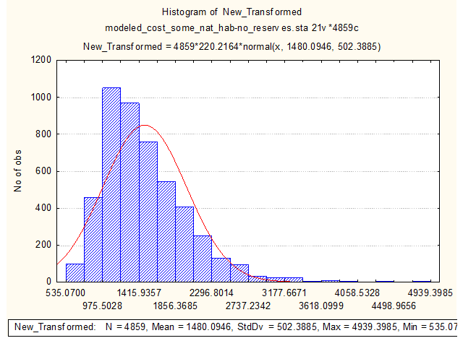

Purchase Costs: accounting for inflation since year 2000

In order to examine the accuracy of the model and to help transform the prices to 2009 levels, I gathered data regarding recent current listing prices of properties at various stages of selling. CapeNature staff provided such data for 42 cadastres. Each one of these was then transformed using the transformation equation, and compared to the cube transformed modeled price of the same cadastre.



The mean ratio among all of these cadastres and their modeled price was 2.32, or a 232% cumulative inflation rate from 2000 through 2008. (If N (the number of known listing prices) were higher, then the median used could come from this sample rather than the model.) This analysis was compared to known inflation rates to see if it was realistic. Property values in the Little Karoo have increased faster than the general inflation rate of all resources the country. Some of the workshop participants say this rate of increase has been about double the rate of inflation. Using the [CIA World Factbook](https://www.cia.gov/cia/publications/factbook/) inflation rates of the South African Consumer Price Inflation Rate, a double inflation rate from 2000 to 2008 would be a cumulative value of 225%, very close to the 232% estimated via the small sample of known properties (Table 4).

Table 4. Calculation of the land price inflation in the Little Karoo from 2000-2008

|  |  |  |  |  |  |
| --- | --- | --- | --- | --- | --- |
|  | | | | | |
|  |  |  |  |  |  |
| Year | SA Consumer Price Inflation Rate | Hypothetical R1000 | 2 X Consumer Inflation Rate | Hypothetical R1000 | Comparing modeled Data with the asking (list) price of 42 cadastres. |
| 2000 | 7 | 1070 | 14 | 1140 |
| 2001 | 6.6 | 1141 | 13.2 | 1290 |
| 2002 | 9.2 | 1246 | 18.4 | 1528 |
| 2003 | 9.9 | 1369 | 19.8 | 1830 |
| 2004 | 5.9 | 1450 | 11.8 | 2046 |
| 2005 | 4.5 | 1515 | 9 | 2231 |
| 2006 | 4 | 1575 | 8 | 2409 |  |
| 2007 | 5 | 1654 | 10 | 2650 |  |
| 2008 | 11.4 | 1842 | 22.8 | 3254 |  |
| Total For 8 yrs: | 84% |  | 225% |  | 232% |

I decided to make the inflation rate a parameter adjustable by the workshop participants, with a default value of 232%. The resulting histogram is displayed in Figure 4. These calculations were presented at the September Workshop and 232% was agreed upon for this iteration of the model.

Figure 4. Histogram of the transformed cost model, with inflation from 2000-2008 estimated at 232%.

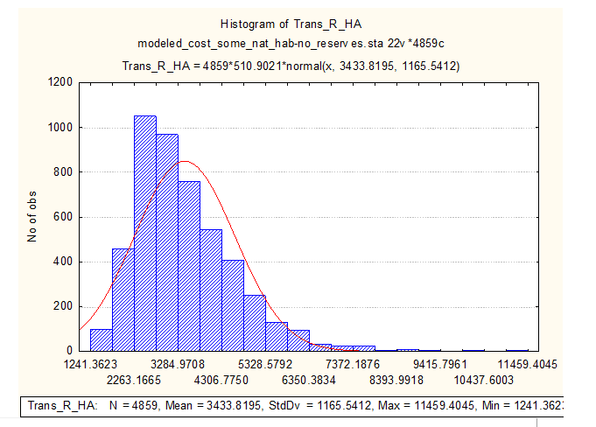

The median value of this final output is 3197 R/HA (~$400 /HA) which is a bit higher than conventional wisdom would dictate. One reason for this is that the model considers all properties that have some natural habitat (a value greater than 0.01 according to the new transformed layer). These properties include many sub-urban and agricultural lands, which have a higher price than the rural lands typically under consideration for conservation, so in this respect the median price seems reasonable. A second reason for the high median price is that the inflation rate was based on the listing price of the properties, not the actual sale price, which can often be less. Hence, end-users should know that the uncertainty of the modeled price may be skewed to the downside. Fortunately, the relative price of all the properties is the same, regardless of the inflation factor used. This relationship is usually more important than absolute value in prioritizing properties for conservation.

Calculation of Management Costs for Acquired Properties

Management of a property by CapeNature is much less expensive if the property adjoins a current reserve. The cost is primarily a function of the property size. If a property is isolated, cost increase substantially. Some cost amounts occur (such as transportation of maintenance crews to and from the site) regardless if the site is 100 HA or 1000 HA. After discussions with managers and revisions at the workshop, the modeled management cost of sites adjacent to reserves is 30 R/HA per year (one Rand is usually worth between $0.10 and $0.14). Isolated sites are estimated to cost 60 R/HA plus 60,000 R a year flat cost regardless of property size. Management cost was then multiplied by 30 years to get the total management cost. These three values are user-defined parameters in the model.

Cost of Stewardship for each property

As mentioned, the LCDSS is supposed to help with other decisions, not just the LHSKT/CN decision. We programmed in the ability to look at stewardship option (i.e. the current landowner maintaining ownership, but signing a contract that the land cannot be developed, for perpetuity.)

Based on meeting with Anita Wheeler in early winter, 2008. (Note: the stewardship department was working on a similar analysis province wide, which should be available for use for future studies.)

Start-up Costs (i.e. securing the agreement)

Initial extension work:

Per visit:

* Transport- R2.61 per KM = R 200
* Time- 2-3 hrs a visit, 1-4 hrs travel time = 5 hrs a visit X R 75 = R 375
* = R575 per visit

Average number of visits needed to result in a **signed** Contract Nature Reserve:

* Needs to consider the unsuccessful “courtship” efforts

Successful courtship:

* For willing landowner: 4-6
* For hesitant but eventually wiling landowner: 10

Unsuccessful courtship:

* For unwilling landowner: 3
* For hesitant but eventually unwilling landowner: 10

Number of each type of landowner:

* Lets say that it is even. Therefore, it is an average of 14 visits.

Total initial extension work =

* R8050 per site

Legal Support

Provided by Capenature to landowner

* Consultation with lawyer R 200
* Rezoning and the new material deed: R 1000
* Public notification, newspaper, etc: R 2000
* Miscellaneous: R1000

Total

* R 4200 per site

Overhead

* Outreach materials, data management, etc
* R 12000 per staff perso per year divided by about 5 contracts a year = R2400

Total Start-up Costs= R 14,650

Maintenance (i.e. Management)

CN Staff

Management plan specific

* Advisory, Mapping, Compiling plant lists, etc..
* About 5 visits per 10 years
* R 287.5 per year

Auditing

* Annually by self, with every third year externally by CN Staff= 1-2 days of work
  + (Salary of ~R 600 per day)
* R 300 per year

Contracted to Public Works

* Working for water, DWAF, etc.
  + E.g. removing aliens, CN commits to 1st clearing, and 2nd and 3rd followup.
* CN channels the money to them.
* R 30,000 – R 60,000 for the first 5 years, less so after that.
  + This is influenced by the number of HA per site (there is some economy of scale, due to decreased relative transport costs)
* R 6 000 -12 000 per year for first 5 years, maybe R 15,000 or so for next 15 years
* Estimated Costs:



References

Cowling, R. M., A. T. Lombard, M. Rouget, G. I. H. Kerley, T. Wolf, R. Sims-Castley, A. Knight, J. H. J. Vlok, S. M. Pierce, A. F. Boshoff, and S. L. Wilson. 2003. A Conservation Assessment for the Subtropical Thicket Biome. Subtropical Thicket Ecosystem Project.

Desmet, P., and R. Cowling. 2004. Using the species–area relationship to set baseline targets for conservation. Ecology and Society **9**:art. 11.

Gallo, J. A., L. Pasquini, B. Reyers, and R. M. Cowling. 2009. The role of private conservation areas in biodiversity representation and target achievement in the Little Karoo, South Africa. Biological Conservation **142**:446:454

Osano, P. M., A. Balmford, M. Rouget, J. Turpie, and W. Thuiller. unpublished. Estimating Land Prices and Opportunity Costs of Conservation in a Megadiversity Country. Contact M. Rouget: Rouget@sanbi.org.

Pasquini, L. 2007. Privately-owned lands and biodiversity conservation: analysing the role of Private Conservation Areas in the Little Karoo, South Africa. University of Sheffield.

Pierce, S. M., R. M. Cowling, A. T. Knight, A. T. Lombard, M. Rouget, and T. Wolf. 2005. Systematic conservation planning products for land-use planning: Interpretation for implementation. Biological Conservation **125**:441-458.

Pressey, R. L., R. M. Cowling, and M. Rouget. 2003. Formulating conservation targets for biodiversity pattern and process in the Cape Floristic Region, South Africa. Biological Conservation **112**:99-127.

Rouget, M., R. M. Cowling, J. H. J. Vlok, M. Thompson, and A. Balmford. 2006. Getting the biodiversity intactness index right: the importance of habitat degradation data. Global Change Biology **12**:2032-2036.

Thompson, M., J. Vlok, M. Rouget, M. T. Hoffman, A. Balmford, and R. M. Cowling. 2008. Mapping land transformation in a heterogeneous environment: a rapid and cost effective approach for assessment and monitoring. Journal of Environmental Management **In Press**.

Thompson, M., J. Vlok, and R. M. Cowling. 2005. A Land Transformation Map for the Little Karoo. GeoterraImage (Pty) Ltd, Pretoria.

Vlok, J., and B. Reyers. Unpublished. Methods, Data, and Results for Determining the Representation Targets for Little Karoo.

Vlok, J. H., R. M. Cowling, and T. Wolf. 2005. A vegetation map for the Little Karoo. Unpublished maps and report for a SKEP project supported by CEPF grant no 1064410304.